Lingual Exercise Effects on the Oropharyngeal Swallow & Dysphagia

Abstract:

In an attempt to improve the quality of life to patients with dysphasia, Dr. Nicole Pulia, Dr. Gangnon and other associates at the Veterans Administration hospital are working diligently to better understand the effects of lingual exercise on the oropharyngeal swallow. To do this, they conducted an eight-week experiment to see if there was a significant relationship between lingual strength and dysphagia symptoms. The experiment consisted of a lingual strengthening program, where patients’ swallows were tested in three different periods: baseline, four-weeks in, and eight weeks in. Finally, the data was then compared across all patients and all swallows to see if there was indeed a significant improvement in quality of life for the dysphasia struggling patients.

Introduction:

Dysphasia, or difficulty swallowing, affects more than 20% of adults over the age of 55(2). Often a consequence of stroke, dysphagia affects about 76% of stroke patients (1). Difficulties include, but not limited to, malnutrition, dehydration, and pneumonia (1). Needless to say, Dysphasia is a common among adults and can significantly affect the patient’s quality of life.

Common short-term solutions for dysphasia are diet modifications and decreased bolus sizes. Unfortunately, these solutions are limiting and does not correct the problem in the long run. Dr. Nicole Pulia, Dr. Gangnon and other associates at the Veterans Administration hospital are hoping that lingual exercise could be a more effective long-term solution for the problem.

In short, the goal is to effectively visualize the huge data set gathered from an eight-week study to get a better understanding of the relationship between dysphasia symptoms and lingual exercise. Since the data set is so large and complex, simply viewing it in a spreadsheet is largely ineffective and inadequate. Thanks to the statistical computing and programming language R, we can express the data how we would like. Furthermore, the web application framework “Shiny” allows the user to interact with the analysis however they wish.

Materials and Methods:

During the eight-week program, participants use the SwallowSTRONG device in their homes. After putting the device in their mouth, they press their tongue against the front and back of the sensor for three sets of ten repetitions per day three times per week. The sensors measure pressure so that the lingual strength of the participant can be tracked over the eight weeks.

The data gathered comes from swallowing tests performed on the patients in three periods: the beginning, four-weeks, and eight-weeks. First, the participants’ swallows were recorded from an X-Ray machine that captures the barium filled boluses. Multiple different types of boluses were swallowed including tsp of nectar, solids, chug honey, puree, pills, etc.

Following the swallows, trained professionals look at the X – Ray frames and record the bolus arrival and structural movement observations. Altogether, the data set contains 1268 observations from 22 different variables including bolus size, bolus type, multiple structural movements, and multiple bolus arrival points during the oropharyngeal swallow.

The next step to better understanding the relationship between lingual strength and dysphagia severity, was to model the sequence of swallow events during the oropharyngeal swallow. First compiled in an excel file, the data set was then read into RStudio. Following the transfer, RStudio’s visualization tools were used to make various “ggplots”—a data visualization package in R. Lastly, a server and user interface were created in a separate folder for “Shiny” which in return deployed an interactive web application:

<https://dundun.shinyapps.io/shinyswallow/>

Results:

In pursuance of an easier and more effective way to visualize the large data set, a “Shiny” application was created. Shiny, created by RStudio, is a web application framework for R that creates an interactive web application displaying your analysis. The Shiny app above allows the user to pick a subject and two swallowing time variables to visualize. Separated into the three experimental periods—baseline, four-weeks, and eight weeks— the graph returned is an easy to visualize representation of the subjects swallow data. Here is the default appearance of the app:

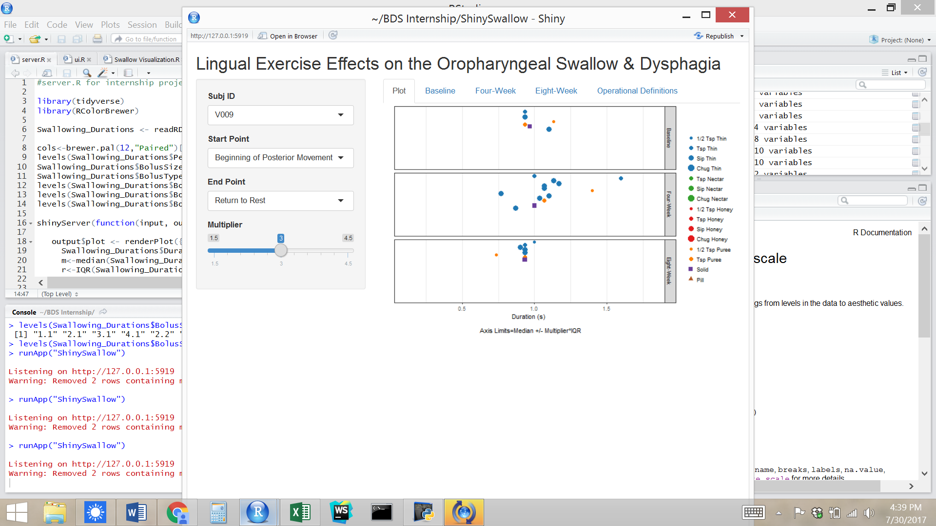

Discussion:

In the shiny application, there is a sidebar panel with three different variables to choose from: Subj ID, Start Point, and End Point. Those three options allow you to choose which subject you would like to look at and which bolus arrival point or structural movement you would like to see visualized. Once all options are chosen, a ggplot will be displayed on the right to express the given data in to three categories: Baseline, Four-week, and eight-week. Below those options is a “Multiplier” that sets the axis limit to be the median plus or minus the chosen multiplier times the interquartile range (IQR). Here is the default appearance of the plot when the multiplier has been changed to 1.5:

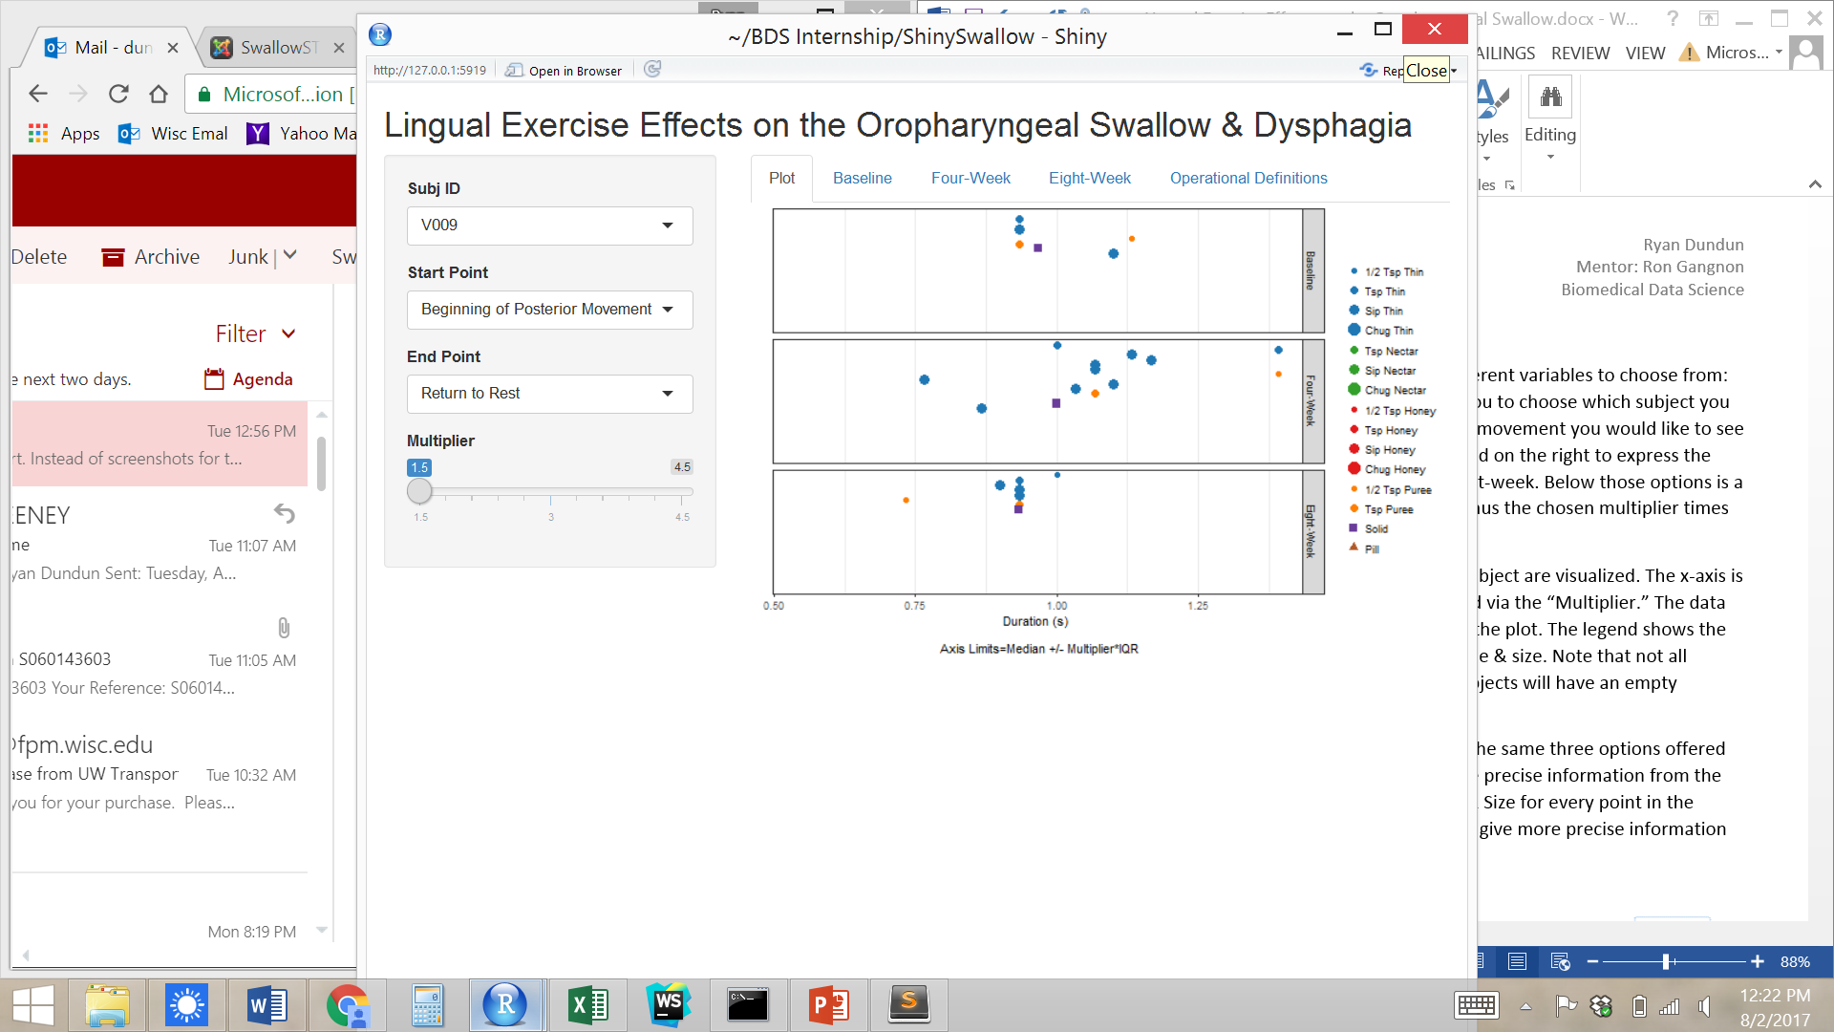

As you move down the y axis, more swallows from the same subject are visualized. The x-axis is the duration of the swallow in seconds, and can be manipulated via the “Multiplier.” The data points are explained via the vertical legend on the right side of the plot. The legend shows the color, size, & shape of the point and its corresponding bolus type & size. Note that not all subjects performed all three of the periods, therefore some subjects will have an empty category/period.

Next to the plot tab, are the three period tabs that depend on the same three options offered in the sidebar panel. When clicked on, the tabs will return more precise information from the plot including the duration of the swallow and the Bolus Type & Size for every point in the respective period. Here is the default for three period tabs that give more precise information about the default plot on page two:

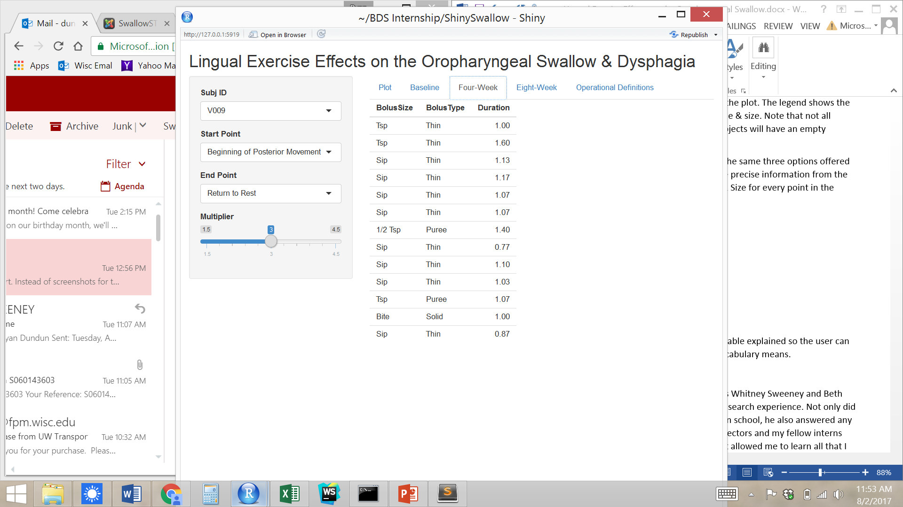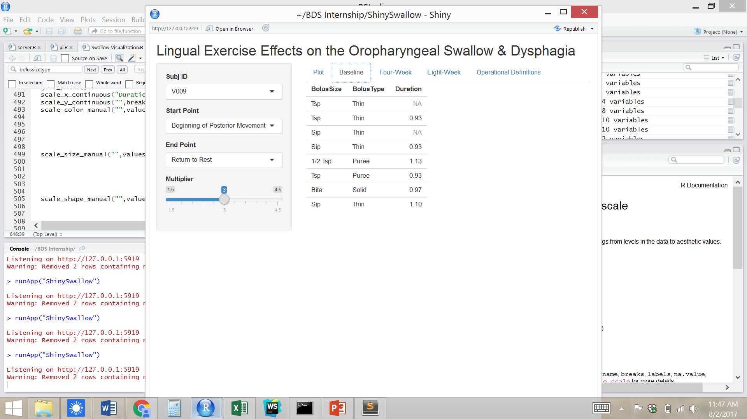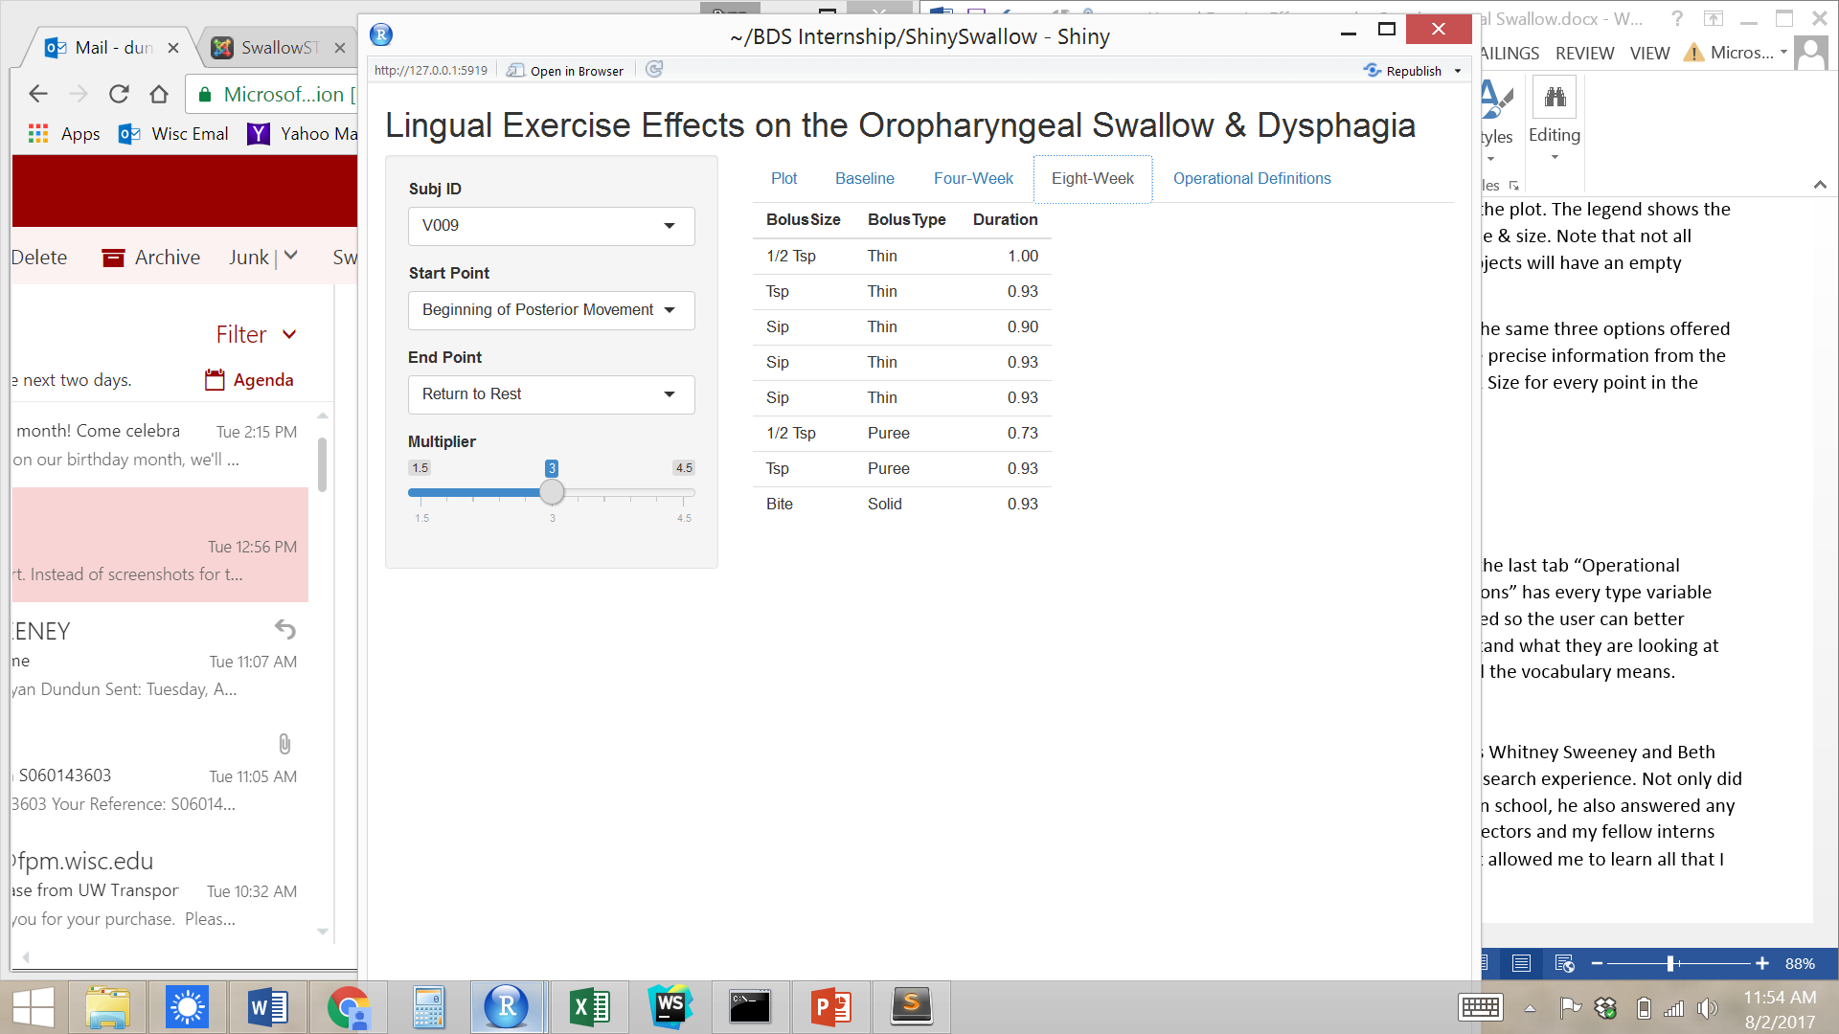

Lastly, the last tab “Operational Definitions” has every type variable explained so the user can better understand what they are looking at and what all the vocabulary means.

Conclusion:

Increased lingual strength is correlated with benefits including improvements in swallowing pressures, airway protection—preventing pulmonary aspiration— and lingual volume. With this knowledge, the hope is that lingual exercise can improve dysphagia symptoms. ShinySwallow, the interactive web application in Shiny, allows for more versatility in duration parameters, observing changes in durations over time, and helps find unusual observations. In short, the Shiny app allows for a more comprehensive exploration of the data

Acknowledgments:

I would like to thank Professor Ron Gangnon, program directors Whitney Sweeney and Beth Bierman, and my fellow interns for an unforgettable summer research experience. Not only did professor Gangnon teach me more about R than I had learned in the classroom, he also answered any questions I had about graduate school and beyond. The BDS directors and my fellow interns helped to make a very welcoming and helpful environment that allowed me to learn all that I could.

References:

1. Robbins, J., S. A. Kays, R. E. Gangnon, J. A. Hind, A. L. Hewitt, L. R. Gentry, and A. J. Taylor. "The effects of lingual exercise in stroke patients with dysphagia." Archives of physical medicine and rehabilitation. U.S. National Library of Medicine, Feb. 2007. Web. 14 June 2017
2. Hind, J. A., M. A. Nicosia, E. B. Roecker, M. L. Carnes, and J. Robbins. "Comparison of effortful and noneffortful swallows in healthy middle-aged and older adults." Archives of physical medicine and rehabilitation. U.S. National Library of Medicine, Dec. 2001. Web. 10 July 2017.

Appendix:

Code for server.r in Shiny App “ShinySwallow”

#server.R for internship project

library(tidyverse)

library(RColorBrewer)

Swallowing_Durations <- readRDS("data/Swallowing_Durations.rds")

cols<-brewer.pal(12,"Paired")[seq(2,12,by=2)]

levels(Swallowing_Durations$Period)= c("Baseline","Four-Week","Eight-Week")

Swallowing_Durations$BolusSize <- factor(Swallowing_Durations$BolusSize)

Swallowing_Durations$BolusType <- factor(Swallowing_Durations$BolusType)

levels(Swallowing_Durations$BolusSize) <- c("1/2 Tsp","Tsp","Sip","Chug","Bite","Pill")

levels(Swallowing_Durations$BolusType) <- c("Thin","Nectar","Honey","Puree","Solid","Pill")

levels(Swallowing_Durations$BolusSizeType)[8]<-NA

shinyServer(function(input, output) {

output$plot <- renderPlot({

Swallowing_Durations$Duration <- (Swallowing_Durations[[input$Time_2]]-Swallowing_Durations[[input$Time_1]])/30

m<-median(Swallowing_Durations$Duration,na.rm=TRUE)

r<-IQR(Swallowing_Durations$Duration,na.rm=TRUE)

tmp<-Swallowing_Durations%>%filter(SubjID==input$SubjID)

ggplot(tmp,aes(x=pmax(m-input$mult*r,pmin(m+input$mult*r,Duration)),y=-BolusNo,color=BolusSizeType,size=BolusSizeType,shape=BolusSizeType))+

geom_point()+

scale_x_continuous("Duration (s) \n \n Axis Limits=Median +/- Multiplier*IQR",limits=m+c(-1,1)*input$mult*r)+facet_grid(Period~.,drop=FALSE)+

scale_y_continuous("",breaks=NULL,limits=range(-Swallowing_Durations$BolusNo))+

scale_color_manual("",values=c("1.1"=cols[1],"2.1"=cols[1],"3.1"=cols[1],"4.1"=cols[1],

"2.2"=cols[2],"3.2"=cols[2],"4.2"=cols[2],

"1.3"=cols[3],"2.3"=cols[3],"3.3"=cols[3],"4.3"=cols[3],

"1.4"=cols[4],"2.4"=cols[4],

"5.5"=cols[5],

"6.6"=cols[6]),

labels=c("1/2 Tsp Thin","Tsp Thin","Sip Thin","Chug Thin",

"Tsp Nectar","Sip Nectar","Chug Nectar",

"1/2 Tsp Honey","Tsp Honey","Sip Honey", "Chug Honey",

"1/2 Tsp Puree", "Tsp Puree","Solid","Pill"),

drop=FALSE,guide=guide_legend(ncol=1,label.position="right"))+

scale_size_manual("",values=c("1.1"=2,"2.1"=3,"3.1"=4,"4.1"=5,

"2.2"=3,"3.2"=4,"4.2"=5,

"1.3"=2,"2.3"=3,"3.3"=4,"4.3"=5,

"1.4"=2,"2.4"=3,

"5.5"=3,

"6.6"=3),

labels=c("1/2 Tsp Thin","Tsp Thin","Sip Thin","Chug Thin",

"Tsp Nectar","Sip Nectar","Chug Nectar",

"1/2 Tsp Honey","Tsp Honey","Sip Honey", "Chug Honey",

"1/2 Tsp Puree", "Tsp Puree","Solid","Pill"),drop=FALSE)+

scale_shape_manual("",values=c("1.1"=16,"2.1"=16,"3.1"=16,"4.1"=16,

"2.2"=16,"3.2"=16,"4.2"=16,

"1.3"=16,"2.3"=16,"3.3"=16,"4.3"=16,

"1.4"=16,"2.4"=16,

"5.5"=15,

"6.6"=17),

labels=c("1/2 Tsp Thin","Tsp Thin","Sip Thin","Chug Thin",

"Tsp Nectar","Sip Nectar","Chug Nectar",

"1/2 Tsp Honey","Tsp Honey","Sip Honey", "Chug Honey",

"1/2 Tsp Puree", "Tsp Puree","Solid","Pill"),drop=FALSE)+

theme_bw()+theme(legend.position="right",legend.direction="vertical")

})

output$swallowtable1 <- renderTable({

Swallowing_Durations$Duration <- (Swallowing_Durations[[input$Time_2]]-Swallowing_Durations[[input$Time_1]])/30

tmp<-Swallowing_Durations%>%filter(SubjID==input$SubjID,Period=="Baseline")

tmp[c("BolusSize","BolusType","Duration")]

})

output$swallowtable2 <- renderTable({

Swallowing_Durations$Duration <- (Swallowing_Durations[[input$Time_2]]-Swallowing_Durations[[input$Time_1]])/30

tmp<-Swallowing_Durations%>%filter(SubjID==input$SubjID,Period=="Four-Week")

tmp[c("BolusSize","BolusType","Duration")]

})

output$swallowtable3 <- renderTable({

Swallowing_Durations$Duration <- (Swallowing_Durations[[input$Time_2]]-Swallowing_Durations[[input$Time_1]])/30

tmp<-Swallowing_Durations%>%filter(SubjID==input$SubjID,Period=="Eight-Week")

tmp[c("BolusSize","BolusType","Duration")]

})

})

Code for ui.r in Shiny App “ShinySwallow”

#ui.R for internship project

shinyUI(fluidPage(

titlePanel("Lingual Exercise Effects on the Oropharyngeal Swallow & Dysphagia"),

sidebarLayout(

sidebarPanel(

# h2("Variables"),

selectInput("SubjID",

label="Subj ID",

choices=list("V004","V009","V012","V020","V022","V029","V034","V036","V039","V040","V043","V044","V045","V046","V048","V049","V051","V052","V054","V059","V061","V064","V065","V066","V067","V069","V070","V075","V076","V077","V079","V081","V082","V083","V090"),

selected="V009"),

selectInput("Time_1",

label="Start Point",

choices=list("Beginning of Posterior Movement"="BeginPosteriorMovement",

"Enter Head in Pharynx"="HeadEnterPharynx",

"Enter Tail in Pharynx"="TailEnterPharynx",

"Begin LVC"="BeginLVC",

"End LVC"="EndLVC",

"Beginning of Maximum Elevation"="BeginMaxElevation",

"First Maximum Elevation"="FirstMaxElevation",

"Last Maximum Elevation"="LastMaxElevation",

"First Maximum Anterior Movement"="FirstMaxAnterior",

"Last Maximum Anterior Movement"="LastMaxAnterior",

"Return to Rest"="ReturnToRest",

"CP Open"="CPOpen",

"Head into CP"="HeadIntoCP",

"Tail in CP"="TailIntoCP",

"CP Closed"="CPClosed"),

selected="Begin Posterior Movement"),

selectInput("Time_2",

label="End Point",

choices=list("Beginning of Posterior Movement"="BeginPosteriorMovement",

"Enter Head in Pharynx"="HeadEnterPharynx",

"Enter Tail in Pharynx"="TailEnterPharynx",

"Begin LVC"="BeginLVC",

"End LVC"="EndLVC",

"Beginning of Maximum Elevation"="BeginMaxElevation",

"First Maximum Elevation"="FirstMaxElevation",

"Last Maximum Elevation"="LastMaxElevation",

"First Maximum Anterior Movement"="FirstMaxAnterior",

"Last Maximum Anterior Movement"="LastMaxAnterior",

"Return to Rest"="ReturnToRest",

"CP Open"="CPOpen",

"Head into CP"="HeadIntoCP",

"Tail in CP"="TailIntoCP",

"CP Closed"="CPClosed"),

selected="ReturnToRest"),

sliderInput("mult",

label="Multiplier",

min=1.5,max=4.5,value=3,step=1.5)

),

mainPanel(

tabsetPanel(

tabPanel("Plot",plotOutput("plot")),

tabPanel("Baseline",tableOutput("swallowtable1")),

tabPanel("Four-Week",tableOutput("swallowtable2")),

tabPanel("Eight-Week",tableOutput("swallowtable3")),

tabPanel("Operational Definitions",

h4(strong("ORAL")),

p(strong("Beginning of Posterior Movement-"),

"Posterior movement of the bolus head which precedes a pharyngeal response. If bolus breaks into two pieces and both are complete swallows, then take duration measures on first swallow only."),

p(strong("Enter Head in Pharynx-"),

"One frame before bolus head crosses the ramus of the mandible. if two rami are visible (i.e., head isn't lateral) use the more posterior as the landmark."),

p(strong("Enter Tail in Pharynx-"),

"Trailing edge of bolus passes ramus of mandible. If two rami are visible (i.e head isn't lateral) use the more posterior as the landmark."),

br(),

h4(strong("HYOID")),

p(strong("Beginning of Maximum Elevation-"),

"The first anterior/superior movement of the hyoid not caused by lingual pumping or jaw movement. Usually hyoid makes rapid movement and looks blurry."),

p(strong("First Maximum Elevation-"),

"The first frame representing most superior point of hyoid excursion. If hyoid reaches max more than once, use the first max."),

p(strong("Last Maximum Elevation-"),

"The last frame which reppresents most superior point of hyoid excursion."),

p(strong("First Maximum Anterior Movement-"),

"The first frame representing most anterior position of hyoid."),

p(strong("Last Maximum Anterior Movement-"),

"The last frame which represents most anterior position of hyoid."),

p(strong("Return to Rest-"),

"Hyoid may not return to starting point. Look for first frame where hyoid has stopped moving posteriorly/inferiorly and is no longer blurred. If hypoid plateaus and then drops due to tongue/jaw movement, take measure at first time of plateau."),

br(),

h4(strong("LARYNGEAL VESTIBULE")),

p(strong("Begin LVC-"),

"The first frame when contact is observed between aryntenoids and base of epiglottis."),

p(strong("End LVC-"),

"The last frame when contact is observed between aryntenoids and base of epiglottis."),

br(),

h4(strong("CRICOPHARYNGEUS")),

p("CP is define as the segment of the upper esophageal sphincter directly posterior to the top of the air column. Locate this segement by drawing an imaginary line from the ubercle of C1 to the anterior/posterior corner of C5 and dropping a perpendicular line to the top of the air column."),

p(strong("CP Open-"),

"Opening is indicted by a white column or lighter shade of gray at CP segment. If not, use frame where bolus enters CP (because it's obviously open then)."),

p(strong("Head into CP-"),

"Head of bolus enters CP. May be same frame as CP Open."),

p(strong("Tail in CP-"),

"Tail of bolus (greater than a wisp) at CP. Do not count residue. If bolus splits, don't include stragglers. Measure the cohesive bolus."),

p(strong("CP Closed-"),

"CP pinches closed, and there is no longer any contrast on top of sphincter. Take the screen of the first CP closure."))

)))

)

)